Chapter 17, Problem 34.

Using Fig. 17.70, design a problem to help other students better understand circuit responses to a Fourier series.
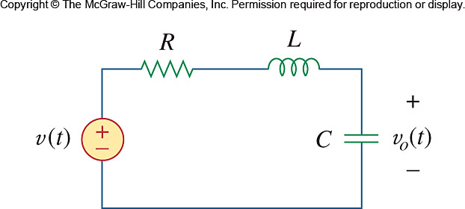

Figure 17.70
For Prob. 17.34.

